|  |  |
| --- | --- |
| **Name** | Ghulam Abbas Muhammad Muneeb |
| **Reg no.** | 2018-EE-361 2018-EE-359 |
| **marks** |  |

**Experiment # 06**

**Economic Dispatch of Generators in the Power System**

**(Lossless system)**

**Objectives:**

To develop a program for solving economic dispatch problem without transmission losses for a given load condition using Lambda-iteration method.

**Introduction:**

In a power system, with negligible transmission losses and with N number of spinning thermal generating units the total system load PD at a particular interval can be met by different sets of generation schedules.



The necessary conditions for the optimal dispatch with losses neglected becomes,

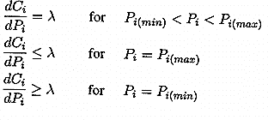

**Task #01**

#### Economic Dispatch of Generators in the Power System (Lossless System)

Perform Economic Dispatch Calculations for the generators of the following power system.

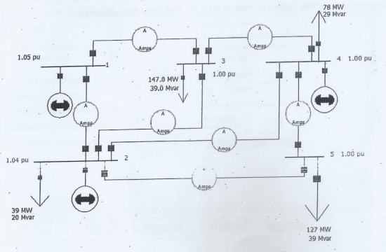

**Figure 1 show the One Line Diagram of lossless power system**

**Cost curves of the generators are:**

C1=10P1+0.016P12 Rs. /hr. [100MW<P1<400MW]

C2=8P2+0.018P22 Rs. /hr. [150MW<P2<500MW]

C3=12P3+0.018P32 Rs. /hr. [50MW<P1<300MW]

**Transmission line data:**

|  |  |  |  |
| --- | --- | --- | --- |
| **Line** | **R** | **X** | **B** |
| L1-3 | 0 | 0.24 | 0.05 |
| L3-4 | 0 | 0.03 | 0.02 |
| L1-2 | 0 | 0.06 | 0.5 |
| L2-5 | 0 | 0.12 | 0.03 |
| L2-4 | 0 | 0.18 | 0.04 |
| L2-3 | 0 | 0.18 | 0.04 |
| L4-5 | 0 | 0.24 | 0.05 |

#### Using PWS

Switch to RUN Mode and open the dialog box of generator 1 and switch to cost tab. Enter the cost curve of the generator in the way shown below.

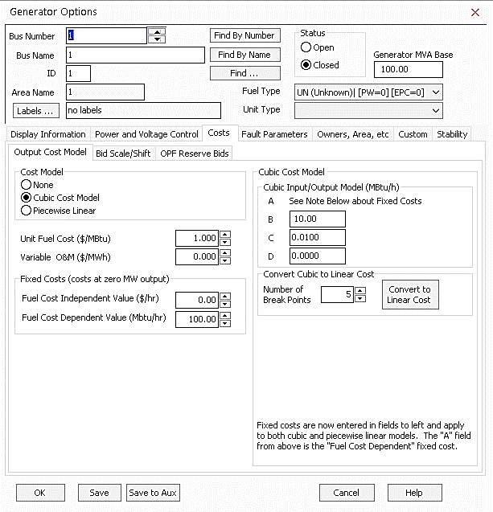

* + Similarly enter the cost data for generator 2 and 3.
  + Open the ‘Model Explorer’, go to areas under the aggregation and switch the AGC status to ED.
  + Switch back to one line diagram and perform the load flow analysis. Your theoretical result should match the simulated result.
  + Right click on any generator to display the generators local menu, and then select “All Area Gen IC Curve”.

**Theoretical Calculation:**

Total load = 391MW

λ= $\frac{P_{D}+\sum_{i=1}^{n}{\frac{β_{i}}{{2γ}_{i}}}}{\sum_{i=1}^{n}{\frac{1}{{2γ}_{i}}}}$

λ= $\frac{391+\left[\frac{10}{2×0.016}+\frac{8}{2×0.018}+\frac{12}{2×0.018}\right]}{\frac{1}{2×0.016}+\frac{1}{2×0.018}+\frac{1}{2×0.018}}$

λ= $\frac{391+312.5+222.22+333.33}{31.25+27.78+27.78}$

λ= 14.503513

Pi =

P1(1) = = 140.8

P2(1) = = 180.6

P3(1) = = 69.60

∆P(1) = 391-(140.735+180.593+69.542) =0

∆P(1) = 0 and the equality constrain is met and P2 and P3 are within limits.

Thus, the optimal dispatch is,

P1(1) = 140.8MW

P2(1) = 180.6MW

P3(1) = 69.60MW

λ= 14.503513$/MWh

Total cost

Ct = 10(140.8) +0.016(140.8)2+8 (180.6) +0.018(180.6)2+12(69.6) +0.018(69.6)2

Ct = 4679.48$/MWh

**One-line diagram:**

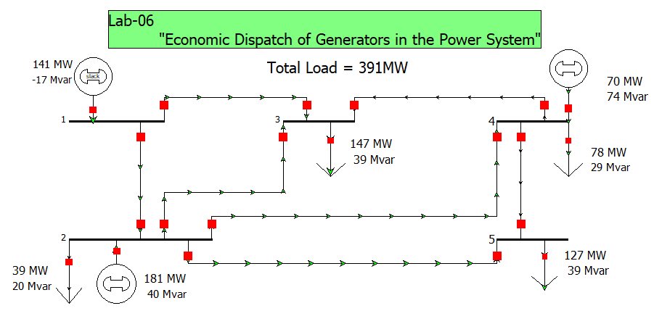

**Figure 2 show the One Line Diagram of lossless power system in PWS**

**Value of λ in PWS:**

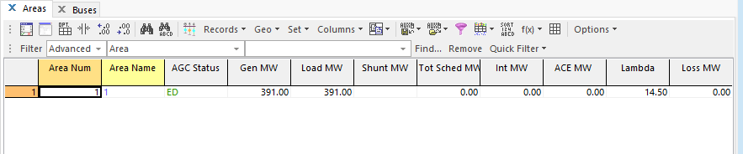

**Figure 3 show the value of Lambda after simulating the power system network**

**Bus information:**

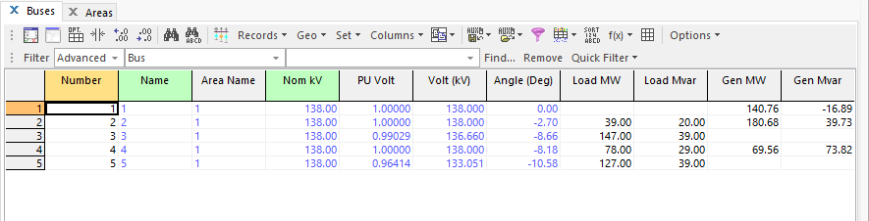

**Figure 4 show the Bus and generators parameters**

**1st Generator Incremental Cost Graph:**

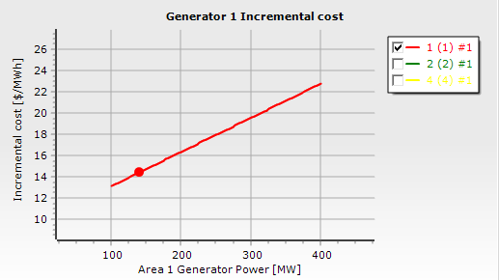

**2nd Generator Incremental Cost Graph:**

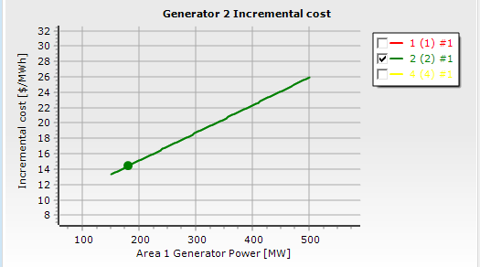

**3rd Generator Incremental Cost Graph:**

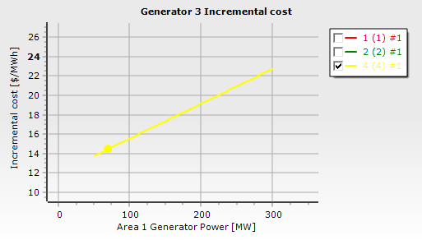

**Assignment:**

Perform the aforementioned calculations for the following three load settings. (What are the incremental costs in each case). Display the incremental cost value in PWS.

1. PD = 1160MW

**Theoretical Calculation:**

λ= $\frac{1160+\left[\frac{10}{2×0.016}+\frac{8}{2×0.018}+\frac{12}{2×0.018}\right]}{\frac{1}{2×0.016}+\frac{1}{2×0.018}+\frac{1}{2×0.018}}$

λ= $\frac{1160+312.5+222.22+333.33}{31.25+27.78+27.78}$

λ= 23.3619

Pi =

P1(1) = = 417.6

P2(1) = = 426.8

P3(1) = = 315.6

∆P(1) = 1160-(417.6+426.8+315.6) =0

∆P(1) = 0 and the equality constrain is met but P1 and P3 are not within limits.

Thus, the optimal dispatch is,

P1(1) = 417.6MW

P2(1) = 426.8MW

P3(1) = 315.6MW

Since generator 1 and 3 are out of limits, So, we have to fix to their maximum Values, and again calculate the generation difference:

∆P(1) = 1160-(400+426.8+300) =33.2

Now, we calculate the new value of lambda:

λ= $\frac{33.2}{27.78}=1.1951$

New value of lambda is as follows:

λ=23.3619+1.1951 = 24.557

P1(2) = 400MW

P2(2) = = 459.91approx 460MW

P3(2) = 300MW

∆P(2) = 1160-(400+46+300) =0

∆P(2) = 0 and the equality constrain is met, P1, P2 and P3 are within limits.

Thus, the optimal dispatch is,

P1(2) = 400MW

P2(2) = 460MW

P3(2) = 300MW

λ = 24.557$/MWh

Total cost

Ct = 10(400) +0.016(400)2+8 (460) +0.018(46)2+12(300) +0.018(300)2

Ct = 19268.8$/MWh

**One-line diagram:**

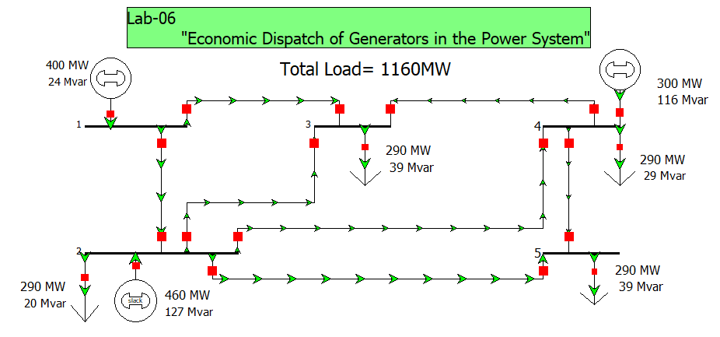

**Figure 5 show the One Line Diagram of lossless power system in PWS**

**Value of λ in PWS:**

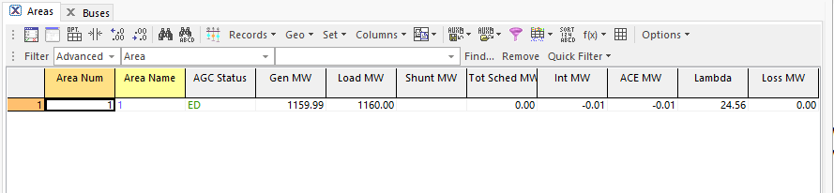

**Figure 6 show the value of Lambda after simulating the power system network**

**Bus information:**

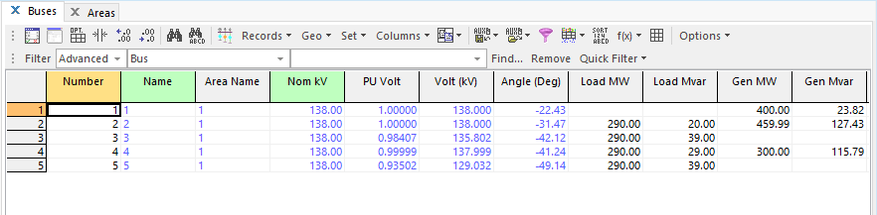

**Figure 7 show the Bus and generators parameters**

**1st Generator Incremental Cost Graph:**

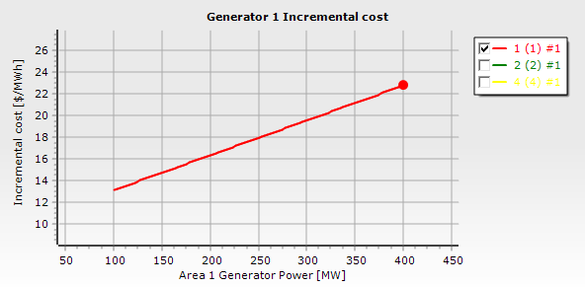

**2nd Generator Incremental Cost Graph:**

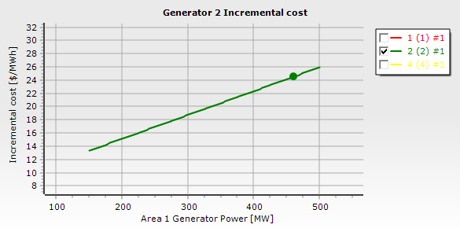

**3rd Generator Incremental Cost Graph:**

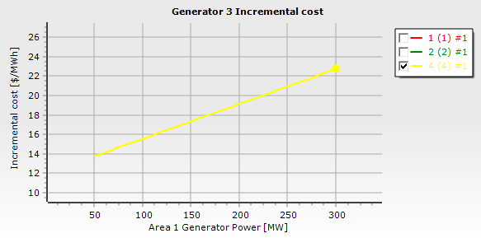

1. PD = 654MW

**Theoretical calculation:**

λ= $\frac{654+\left[\frac{10}{2×0.016}+\frac{8}{2×0.018}+\frac{12}{2×0.018}\right]}{\frac{1}{2×0.016}+\frac{1}{2×0.018}+\frac{1}{2×0.018}}$

λ= $\frac{654+312.5+222.22+333.33}{31.25+27.78+27.78}$

λ= 17.5331

Pi =

P1(1) = =235.5

P2(1) = = 264.9

P3(1) = =153.6

∆P(1) = 654-(235.5+264.9+153.6) =0

∆P(1) = 0 and the equality constrain is met and P2 and P3 are within limits.

Thus, the optimal dispatch is,

P1(1) = 235.5MW

P2(1) = 264.9MW

P3(1) = 153.6MW

λ= 17.5331$/MWh

Total cost

Ct = 10(235.5) +0.016(235.5)2+8 (264.9) +0.018(264.9)2+12(153.6) +0.018(153.6)2

Ct = 8892.53$/MWh

**One-line diagram:**

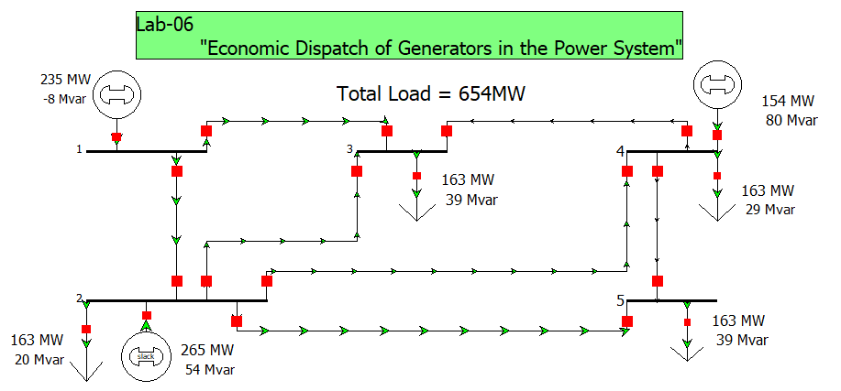

**Figure 8 show the One Line Diagram of lossless power system in PWS**

**Value of λ in PWS:**

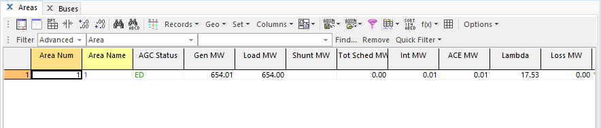

**Figure 9 show the value of Lambda after simulating the power system network**

**Bus information:**

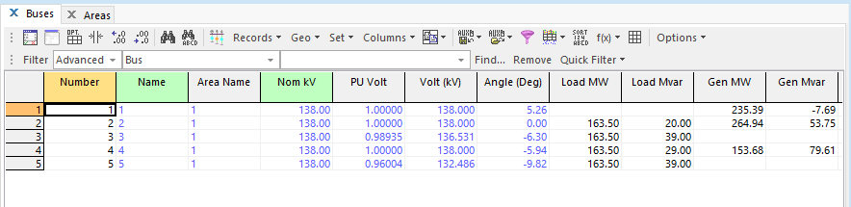

**Figure 10 show the Bus and generators parameters**

**1st Generator Incremental Cost Graph:**

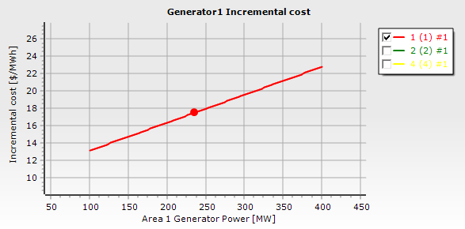

**2nd Generator Incremental Cost Graph:**

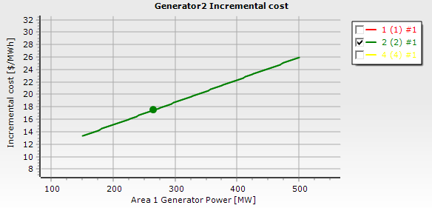

**3rd Generator Incremental Cost Graph:**

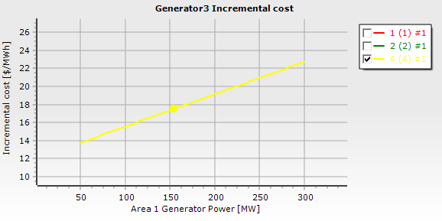

1. PD = 300MW

**Theoretical Calculation:**

λ= $\frac{300+\left[\frac{10}{2×0.016}+\frac{8}{2×0.018}+\frac{12}{2×0.018}\right]}{\frac{1}{2×0.016}+\frac{1}{2×0.018}+\frac{1}{2×0.018}}$

λ= $\frac{300+312.5+222.22+333.33}{31.25+27.78+27.78}$

λ= 13.4552

Pi =

P1(1) = =108

P2(1) = = 151.5

P3(1) = =40.5

∆P(1) = 300-(108+151.5+50) =-9.5

The equality constrain is not met because P3 is not within limits.

Thus, the optimal dispatch is,

P1(1) = 108MW

P2(1) = 151.5MW

P3(1) = 50MW

Since generator 3 is out of limits, So, we have to fix to their maximum Value and again calculate the generation difference:

∆P(1) = 300-(108+151.5+50) =-9.5

Now, we calculate the new value of lambda:

λ= $\frac{-9.5}{31.25+27.78}=-0.1609$

Updated value of lambda is as follows:

λ=13.4552-0.1609 = 13.2943

P1(2) = 103MW

P2(2) = = 147MW

P3(2) = 50MW

∆P(2) = 300-(103+147+50) =0

∆P(2) = 0 and the equality constrain is met, P1, P2 and P3 are within limits.

Thus, the optimal dispatch is,

P1(2) = 103MW

P2(2) = 147MW

P3(2) = 50MW

λ = 13.2943$/MWh

Total cost

Ct = 10(103) +0.016(103)2+8 (147) +0.018(147)2+12(50) +0.018(50)2

Ct = 3409.7$/MWh

**One-line diagram:**

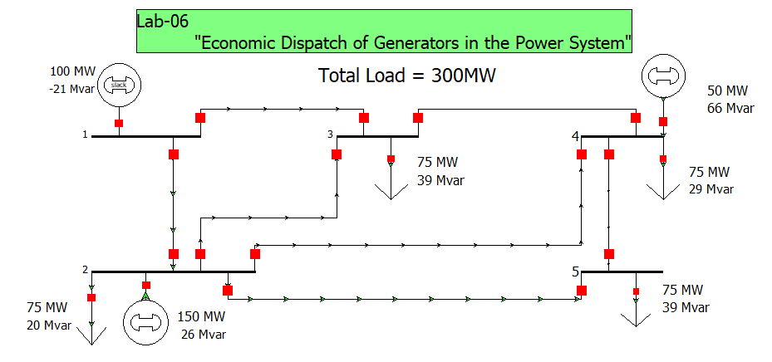

**Figure 11 show the One Line Diagram of lossless power system in PWS**

**Value of λ in PWS:**

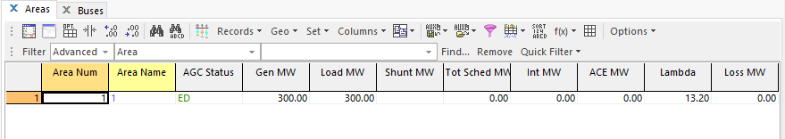

**Figure 12 show the value of Lambda after simulating the power system network**

**Bus information:**

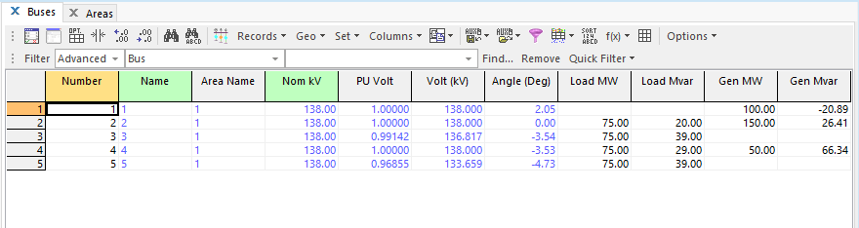

**Figure 13 show the Bus and generators parameters**

**1st Generator Incremental Cost Graph:**

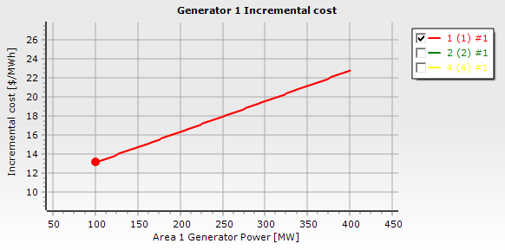

**2nd Generator Incremental Cost Graph:**

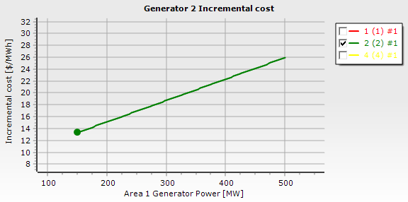

**3rd Generator Incremental Cost Graph:**

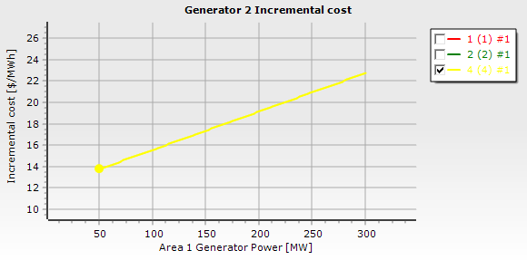

**Results:**

|  |  |  |  |  |  |
| --- | --- | --- | --- | --- | --- |
| **Load (MW)** | **Generation (MW)**  **P1 P2 P3** | | | **Incremental cost (λ)** | **Total Cost**  **($/MWh)** |
| 391 | 140.8 | 180.6 | 69.60 | 14.5035 | 4679.48 |
| 1160 | 400 | 460 | 300 | 24.557 | 19268.8 |
| 654 | 235.5 | 264.9 | 153.6 | 17.5331 | 8892.53 |
| 300 | 103 | 147 | 50 | 13.2943 | 3409.7 |

**Conclusion:**

In this lab, we learn about solving economic dispatch problems without transmission line losses of given power system network. We use lambda iteration method to carry out the solution of economic dispatch problems. We verify our results by matching the theoretical calculation with the simulation results carried out by developing one-line diagram of given power system network in power world simulator software.